**MARKET BASKET ANALYSIS - *Electronidex* Buy Exploration**

The research areas covered

* Do *Electronidex’s* transactions determine if it will be a good acquisition for us?
* The report includes findings from a market basket analysis of *Electronidex’s* transactions in a 30-day period.
* The report focuses on looking for patterns or items relationships between our products and *Electronidex’s* products as well as the business benefits of a hypothetical acquisition of *Electronidex*.

Recommendations

The recommendation is that we should seriously consider purchasing *Electronidex*. This advice is based on the following:

* Electronidex sells to both B2B and B2C customers and this would open up the B2B market to Blackwell’s, as demonstrated by the figure below.

*Electronidex’s Items sold per Blackwell categories and customer type*

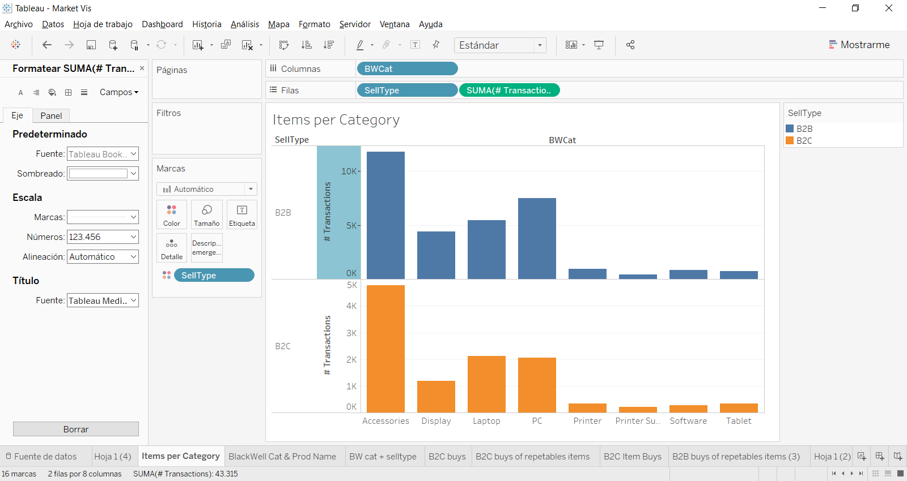

* Due to the nature of *Electronidex’s* customer base of B2B customers with high revenue per order, the share of its sales in profitable products (laptops, desktops and displays) is high. In contrast, our sales are currently underperforming in these product types (compared to other categories like Accessories).

This is an opportunity for us to create greater synergies between different product types.

* We would pick up repeated transactions from B2B customers. B2B electronics customers are high spending and loyal than B2C customers.
* *Electronidex* has a successful cross-selling market pattern on selling accessories in B2C transactions and display category in B2B.

These patterns are something that Blackwell’s could benefit from. We are already specialized in selling accessories, and the acquisition would strengthen our specialization to our main customers (B2C).

Points to consider for further research

It is recommended that the investigation into whether or not to purchase *Electronidex* continues with an investigation into the following points:

1. The dataset from *Electronidex* is for 30 days but the actual month isn’t specified. Some months, for example leading up to Christmas or those including days such as Black Friday, will have inflated sales figures. An investigation should include finding out if these figures are typical.
2. The Blackwell dataset used to compare sales figures has only 80 observations and the time period is unknown. A further investigation should include making sure that the Blackwell and *Electronidex* datasets are comparable in terms of time period and time of the year, and a larger dataset for Blackwell’s.
3. It could also be prudent to carry out a data analysis of *Electronidex’s* profit margins, most profitable products, and spend per transaction, and compare these with Blackwell’s.

Findings and conclusions from the analysis

The analysis was divided into two parts because *Electronidex* sells to both B2B (bulk orders) and B2C customers, and the buying habits of this two groups are very different. The division was performed following the pattern below:

* If a transaction has more than one item of the following *Electronidex* categories, it would be considered B2B: Laptop, Desktop, Monitor, Printer, Mouse/Keyboard.
* Otherwise, it would be considered B2C.

The Insightful Rules Category

*1. B2B customers*

Blackwell’s sales of displays and laptops are low (see Figure 1 in the Appendix). These are higher sellers for *Electronidex* (see Figure 8 in the Appendix) and many of the rules for B2B customers based on product categories, suggest their customers will go on to buy a display (see Figures 9 and 10 in the Appendix). Blackwell would benefit from selling these items through *Electronidex*.

Product types such as printer supplies and software appear repeatedly on the left-hand side of the rules suggesting that these are repeat customers who already have their desktop computers. Such purchases are likely to lead to purchases of additional monitors and laptops.

*2. B2C customers*

The rules associated with a market basket analysis of *Electronidex’s* B2C customers shows that Blackwell’s could solidly or eventually increase sales of accessories if it acquires Electronidex (see Figures 5 and 6 in the Appendix).

The Irrelevant Rules Category

An analysis based on brands did not produce any meaningful results for B2B customers. An interesting fact is that *Electronidex’s* B2B customers tend to buy a variety of hardware (desktops, laptops) and do not keep to one specific brand (For example, they buy 2 desktops, 2 monitors, and an iMac for the graphic designer).

This is something that could be analyzed further. However, in terms of this report, it is clear that an item’s product type is a stronger determinant of basket rules than brand.

It will come as no great surprise that there is an exception relating to Apple products and B2C customers, where we found 2 very strong rules that identifies ‘Apple lover’ customers.

*The process for modelling the data is in the *Appendix: The Process*.

Appendix: The process

This appendix is organised into the following stages:

1. Observations about Blackwell’s sales
2. Observations about Electronidex’s transactions and pre-processing the data
3. B2C market basket analysis aggregated by categories
4. B2B market basket analysis aggregated by categories
5. Market basket analysis aggregated by brand

1. Observations about Blackwell’s sales

Plots of Blackwell’s sales data help to determine if Electronidex is a good acquisition. Figure 1 shows that accessories are the biggest seller for Blackwell’s even though they have low profitability, as shown in Figure 2.

*Figure 1: Sales volumes by product type*

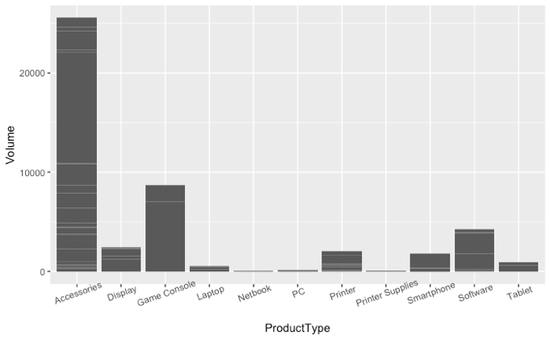

*Figure 2: Volume and profit margin with product type as the colour*

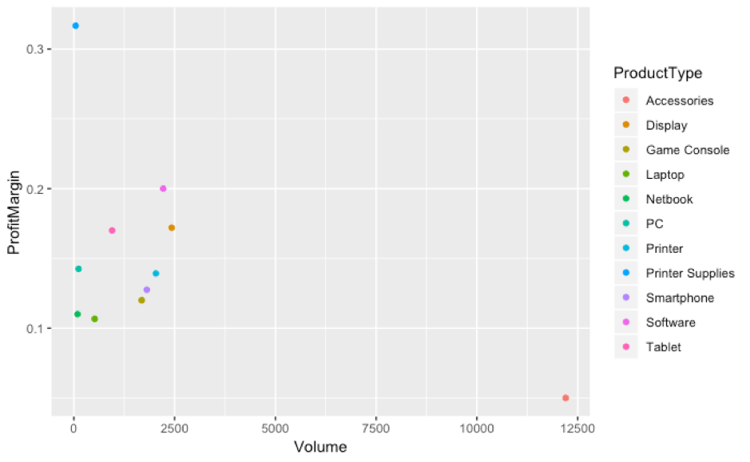

2. Observations about Electronidex’s transactions and pre-processing the data

It is clear from a first inspection of Electronidex’s transactions that it is selling to both B2B and B2C customers. Some transactions include, for example, more than one desktop, printer or laptop – it is most likely that these transactions are being made by B2B customers. Blackwell’s customers cannot be identified in this way.

Two independent transaction files were created for B2B and B2C transactions. When differentiating between B2B and B2C sales, it is clear in Figure 3 that some products are bought more by one customer type than the other.

*Figure 3: Percentage of buys-per-total in Electronidex’s transactions*

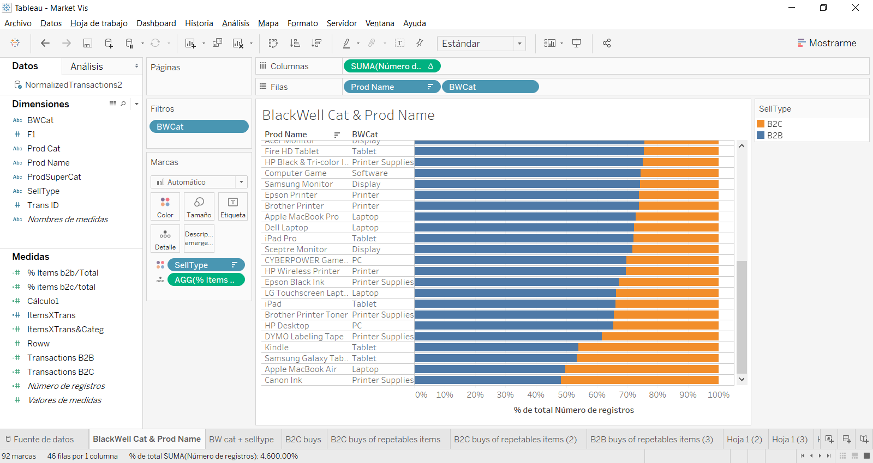

Within these transaction files, a new level was added called ‘categories’. The eight categories correspond to the product types in Blackwell’s database:

1. Display
2. Accessories
3. Printer
4. Printer supplies
5. Tablet
6. Software
7. PC
8. Laptop

After dividing into 2 subcategories (B2B, B2C), new labels are added enabling rules to be produced by product type, such as desktop or laptop, rather than individual products. These categories correspond to those in one of Blackwell’s datasets. This will prove to be useful when it comes to considering the company as a possible acquisition for Blackwell’s.

3. B2C market basket analysis aggregated by categories

Regarding the B2C sales, the distribution over the different categories is very similar to the overall transactional file, or B2B distribution, as can be seen in Figure 4 below. This figure also includes the relationship between Blackwell’s product categories and Electronidex categories.

*Figure 4: Number of items sold (by BW-category and Electonidex Category) to B2C customers*

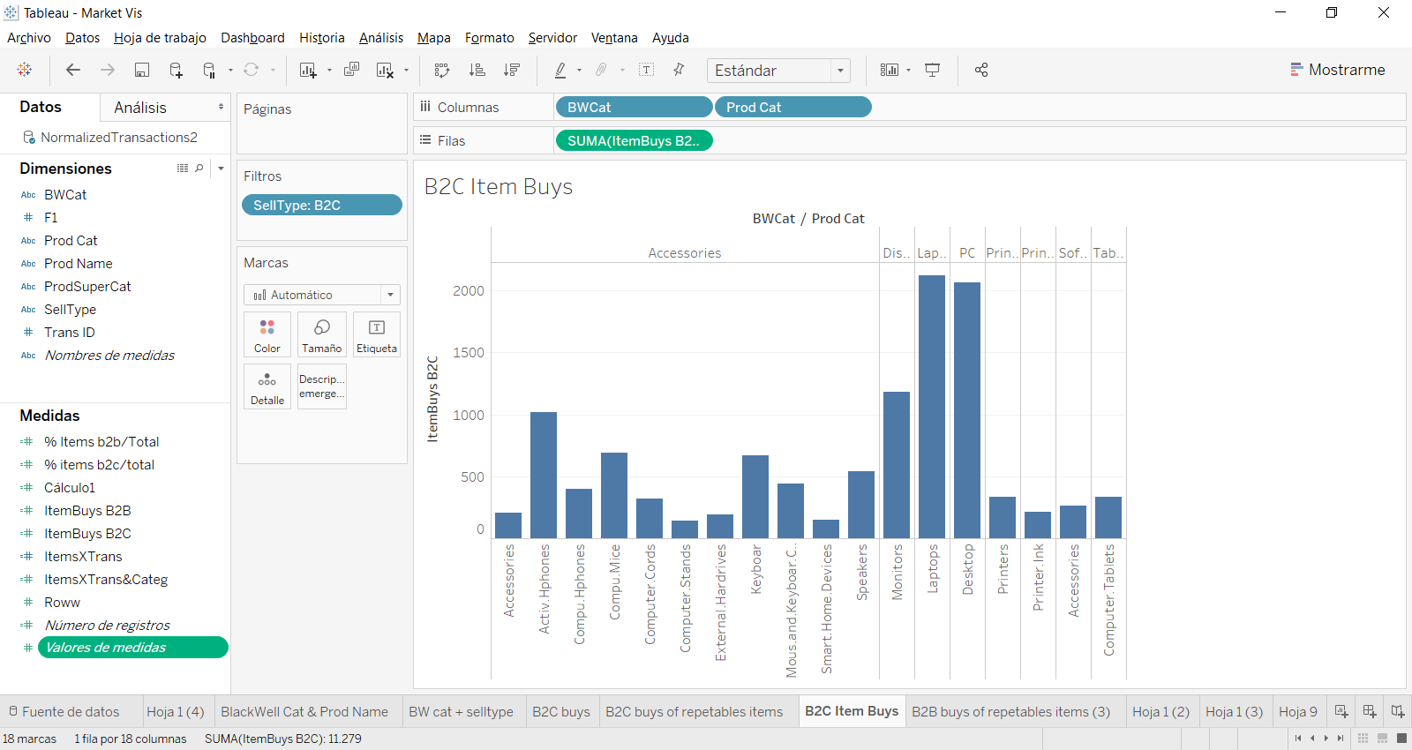

*3.1*  *Meaningful patterns in Electronidex’s orders*

It is difficult to define typical buying patterns in the B2C transactions because dispersion is high. Even so, accessories is the one category that clearly benefits as can be seen in Figure 5.

The graph in Figure 5 corresponds to 626 B2C transactions that follow these rules (10% of total). The size of the rule relates to the number of time it happens and the darker the colour, the more confident the rule is.

*Figure 5: graph of B2C rules*

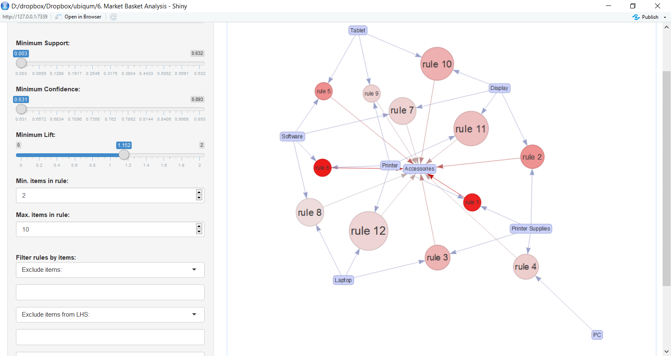

We clearly see that mostly all categories point into accessories, meaning that when customers shop on the Electronidex’s website, they are likely to buy accessories along with other categories.

The detail in the basket analysis for B2C transactions is shown in Figure 6.

*Figure 6: table of B2C rules*

|  |  |  |  |  |  |
| --- | --- | --- | --- | --- | --- |
| First products added to basket | Final product added to basket | support | confidence | lift | #Trans. |
| {Printer,Printer Supplies} | {Accessories} | 0,005 | 0,889 | 1,409 | 24 |
| {Display,Printer Supplies} | {Accessories} | 0,010 | 0,815 | 1,292 | 53 |
| {Laptop,Printer Supplies} | {Accessories} | 0,012 | 0,778 | 1,233 | 63 |
| {PC,Printer Supplies} | {Accessories} | 0,012 | 0,747 | 1,184 | 62 |
| {Software,Tablet} | {Accessories} | 0,003 | 0,818 | 1,297 | 18 |
| {Printer,Software} | {Accessories} | 0,005 | 0,893 | 1,415 | 25 |
| {Display,Software} | {Accessories} | 0,013 | 0,742 | 1,175 | 66 |
| {Laptop,Software} | {Accessories} | 0,014 | 0,730 | 1,157 | 73 |
| {Printer,Tablet} | {Accessories} | 0,004 | 0,742 | 1,176 | 23 |
| {Display,Tablet} | {Accessories} | 0,014 | 0,783 | 1,240 | 72 |
| {Display,Printer} | {Accessories} | 0,015 | 0,764 | 1,211 | 81 |
| {Laptop,Printer} | {Accessories} | 0,018 | 0,738 | 1,170 | 96 |

4. B2B market basket analysis aggregated by categories

*4.1 Plots of Electronidex’s sales*

Figure 7 shows that the biggest sellers for Electronidex are iMac desktop, HP Laptop, Gamer desktop, Apple earpods, Apple Macbook Air. Figure 8 shows that, in terms of product types, the biggest seller for Electronidex is accessories and this is closely followed by PCs.

*Figure 7: frequency of items purchase*

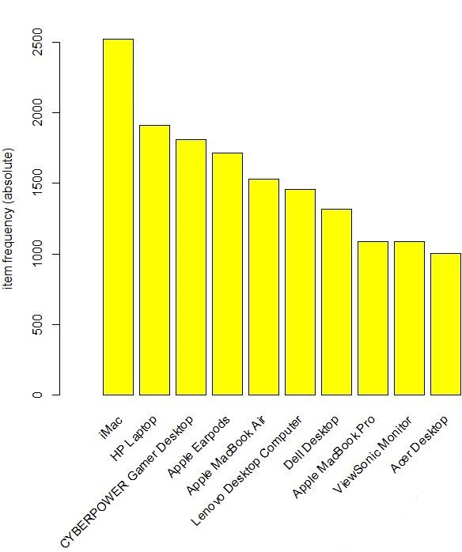

*Figure 8: frequency of product types purchase*

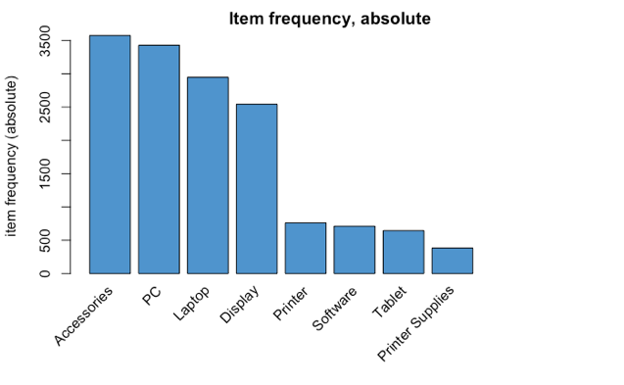

*4.2* *Apply the Apriori algorithm*

The Apriori algorithm is applied to the transaction file aggregated by categories, and the support, confidence and lift parameters adjusted to obtain the optimum rules with the highest lift and confidence values. Figures 9 and 10 show the top rules as a table and graphically.

*Figure 9: table of B2B rules*

(2300 transactions follow these rules, >50% of the total)

|  |  |  |  |  |  |
| --- | --- | --- | --- | --- | --- |
| First products added to basket | Final product added to basket | support | confidence | lift | #Trans. |
| {Accessories,Software} | {Display} | 0,109 | 0,723 | 1,238 | 500 |
| {PC,Software} | {Display} | 0,102 | 0,739 | 1,266 | 470 |
| {Laptop,Software} | {Display} | 0,090 | 0,723 | 1,240 | 413 |
| {Laptop,Printer Supplies} | {Display} | 0,052 | 0,741 | 1,269 | 240 |
| {Printer,Tablet} | {Display} | 0,031 | 0,809 | 1,386 | 144 |
| {Printer,Software} | {Display} | 0,031 | 0,797 | 1,365 | 141 |
| {Software,Tablet} | {Display} | 0,023 | 0,723 | 1,239 | 107 |
| {Printer,Printer Supplies} | {Display} | 0,020 | 0,788 | 1,351 | 93 |
| {PrinterSupplies,Software} | {Laptop} | 0,019 | 0,889 | 1,306 | 88 |
| {Printer Supplies,Software} | {Display} | 0,016 | 0,747 | 1,281 | 74 |
| {Printer Supplies,Tablet} | {Display} | 0,015 | 0,758 | 1,299 | 69 |

*Figure 10: graph of the rules for B2B customers*

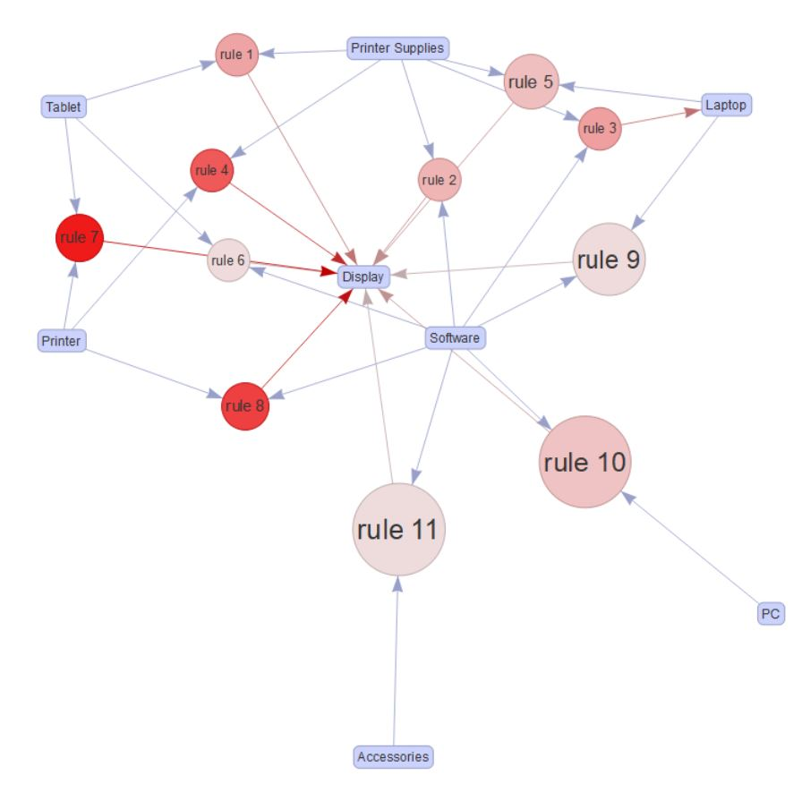

*4.3* *B2B categories conclusions*

There is a clear pattern in the rules. When a B2B customer buys the products in the combinations shown above, they are likely to go on to buy a display.

5. Market basket analysis aggregated by brand

The results that were generated in a market basket analysis of B2B customers based on brands don’t show any meaningful patterns and leads to the conclusions that the analysis will not add value to an assessment of whether or not Blackwell’s should acquire Electronidex. Any one brand has many different product types and the brand alone doesn’t determine the purchasing decision.

The unique exception occurs with Apple products in B2C rules, where we found 2 very strong rules (lifts of 66 and 49) that identifies ‘Apple lover’ customers, as we see in the following table:

*Figure 11: table of B2C rules by Apple brand*

|  |  |  |  |  |  |
| --- | --- | --- | --- | --- | --- |
| **LHS** | **RHS** | **support** | **confidence** | **lift** | **count** |
| {Apple Earpods,Apple MacBook Air,iPhone Charger Cable} | {Dell KM117 Wireless Keyboard & Mouse} | 0,001 | 0,75 | 66,46 | 6 |
| {Apple Earpods,Apple MacBook Air,Dell KM117 Wireless Keyboard & Mouse} | {iPhone Charger Cable} | 0,001 | 0,86 | 48,71 | 6 |